Lab 7 Part 1: Programming

1

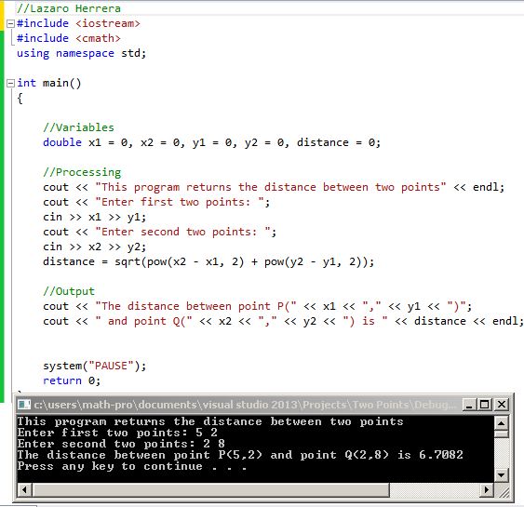

2

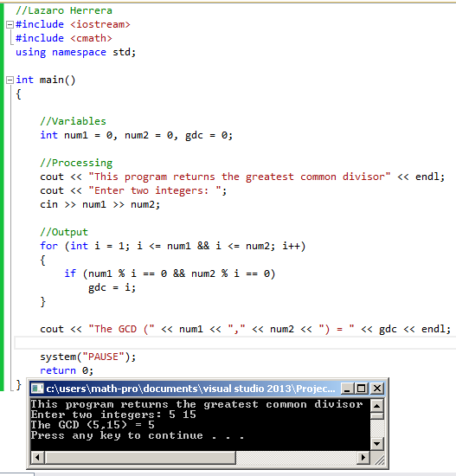

3

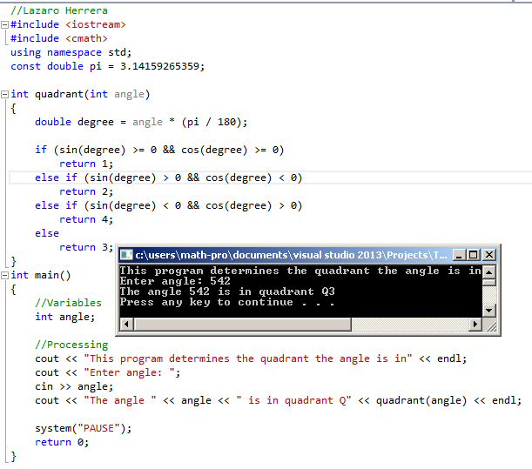

Lab 7 Part 2: Programming output

4.-5  
 5.49  
 -6

5.10  
 5

6. 6